**Measure energy consumption:**

**Abstract**

Energy consumption information for devices, as available in the literature, is typically obtained with ad hoc approaches, thus making replication and consumption data comparison difficult. We propose a process for measuring the energy consumption of a software application. The process contains four phases, each providing a structured deliverable that reports the information required to replicate the measurement. The process also guides the researcher on a threat to validity analysis to be included in each deliverable. This analysis ensures better reliability, trust, and confidence to reuse the collected consumption data. Such a process produces a structured consumption data for any kind of electronic device (IoT devices, mobile phones, personal computers, servers, etc.), which can be published and shared with other researchers fostering comparison or further investigations. A real case example demonstrates how to apply the process and how to create the required deliverables.

#### 1. Introduction

A software program contains a sequence of instructions whose execution requires the device on which it is running to consume energy. Today, energy consumption, a nonfunctional property of the program, is seldom considered upfront as a nonfunctional requirement or, after the fact, as a property to be measured and monitored. However, energy consumption may represent a critical problem for end users. In laptops, tablets, and smartphones, energy consumption clearly has an impact on battery life and, therefore, it becomes a user experience issue. For data centres or Bitcoin miners, energy consumption has a direct impact on the electrical bill. In the literature, many have addressed the problem of measuring and reducing energy consumption but typically in an ad hoc manner.

According to the evidence-based software engineering (EBSE)approach, concrete decision-making should be supported by the empirical evidence available in the literature. Such evidence must be trustable, produced through a documented and repeatable process, contextualised, and linked to the context where it can be applied, identifiable, address a well-defined question, assessable, and report the known limitations of the results. Such characteristics are seldom present in most of the related published literature.

**2. Select unit of measurement:**  
**void** counting_sort (**int***A*[], **int***n*

{

**int***i*, ,;

*B* = malloc (*n***sizeof** (**int**));

*C* = malloc (*M***sizeof** (**int**));

**for** (*i* = 0; *i* < *M*; *i*++)

*C*[*i*] = 0;

**for** (*i* = 0; *i* < *n*; *i*++)

*C*[*A*[*i*]]++;

**for** (*i* = 1; *i*< *M*; *i*++)

*C*[*i*] + = *C*[*i* − 1];

**for** (*i* = *n* − 1; *i* ≥ 0; *i*−−){

*B*[*C*[*A*[*i*]] − 1] = *A*[*i*];

C[A]-j

}

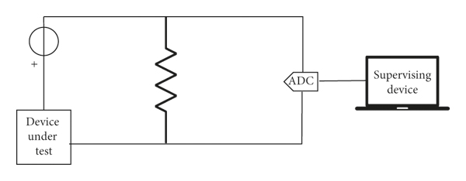

Graph:   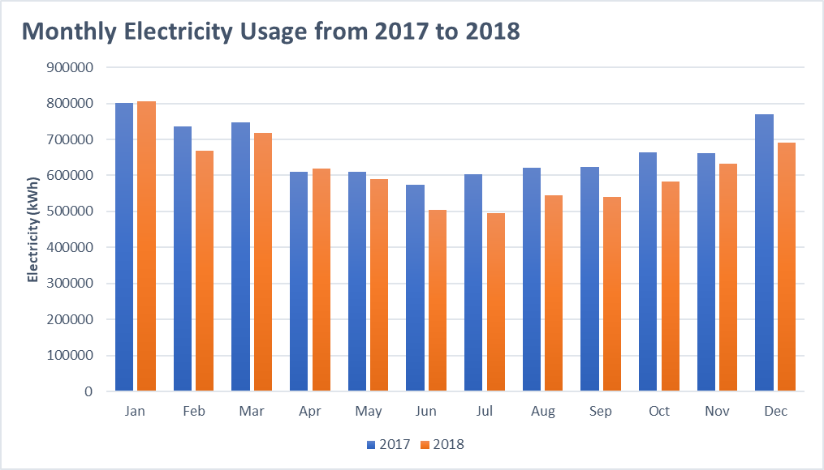

To calculate standby power:

Energy consumption defines the use of energy. It is the use of energy specifically for a definite amount. This is related to the energy consumption of electrical power generated through power plants or energy used by any living creature. Both types of consumption of energy vary from each other. Joules is the term used to scale energy as a standard unit of measurement, hence the energy is generally observed as gigajoules per year. The formula to calculate energy is derived for the calculation of consumed energy in a specific period. The formula for Energy ConsumptionThe formula of energy is used to calculate the use of energy for a given period. The consumption of energy is measured by multiplying the number of power units consumed in a given period. The formula for consumption of energy is given below-

E = P*(t/100)

In this formula, E refers to the measured Joules or kilowatt per hour (kWh).P refers to power used per unit in watts.

t refers to the time over which the power .

3.Analyse and adjust:

The energy review requires that you collect energy use and consumption data and analyze it to:

* Determine significant energy uses.
* Identify energy opportunities.
* Develop End.
* Establish baselines .
* Set energy performance objectives and targets.
* Monitor energy performance.

Conclusion:

To curb and control the harmful effects of energy consumption, energy conservation is necessary. Energy conservation is the practice of decreasing the total quantity of energy or using the energy more efficiently and avoiding any wastage of energy.